**Paper Airplane**

2008

Alex Vassallo

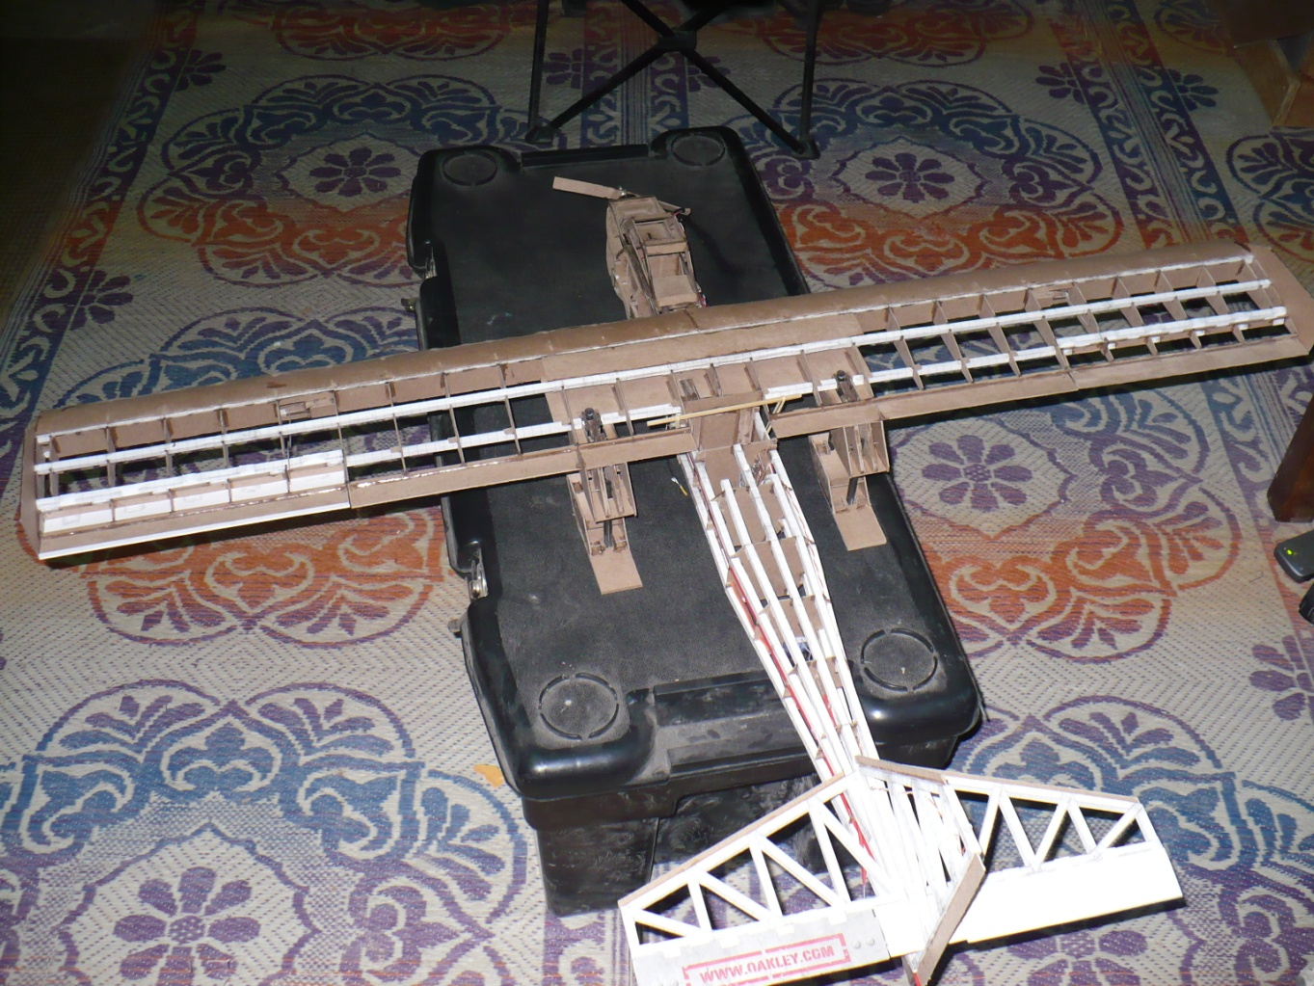

This project was started and completed while serving on duty during Operation Iraqi Freedom. The material used for construction was nothing more than the thin cardboard found on the back of our notepads, the lined paper from it, superglue from the supply tent, paperclips, coffee straws, thumbtacks, cigarette cellophane, and the hardware found in retractable pens. The one exception to local material was the 6 channel R/C transmitter that a family member had specially shipped to me.

This project began with detailed and scaled drawings done on graph paper. The airfoil chosen was a Clark 'Y' airfoil due to the high lift, slow stall speed, and overall simplicity requirements. The width and length of the wings, (chord and wingspan), was designed short and stubby to allow for large error tolerances during construction and responsiveness of controls during flight, while maintaining appropriate surface area for the projected weight. The tail section was placed slightly closer to the center of gravity than normal, to allow for more responsive controls rather than overall stability during straight flight. The terrain that this craft would be landing on would normally be dirt and rock, so aluminum (soda cans) covered landing skids rather than wheels were chosen, and would be retractable due to the high drag they create. Lastly, because we had just captured a small mouse who had been caught attempting to steal from our food stash, it was decided that the mouse should 'pilot' this craft. Since no animals could be harmed during this project, an ejection seat was designed in the case of catastrophic failure.

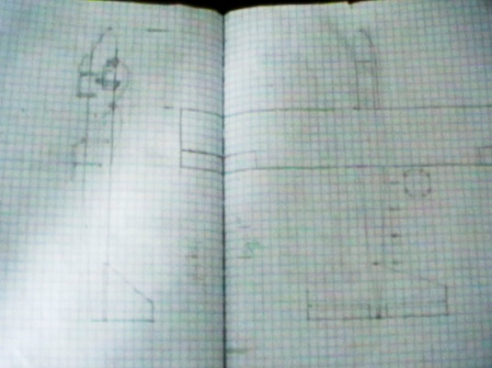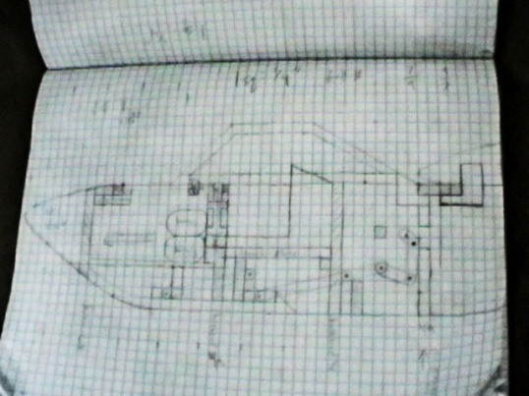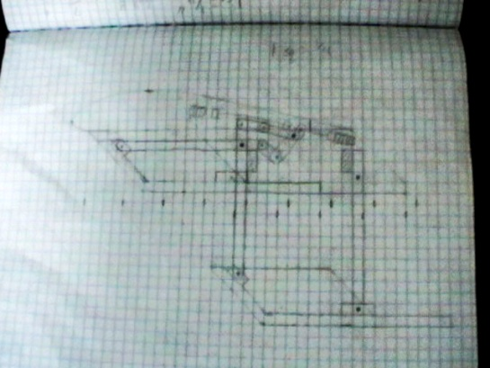Below are the original sketches from Iraq that survived. I used graphing paper to produce scale models.

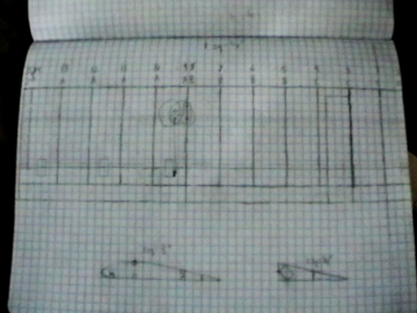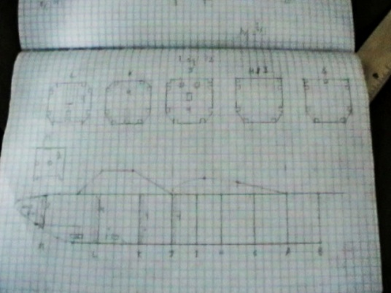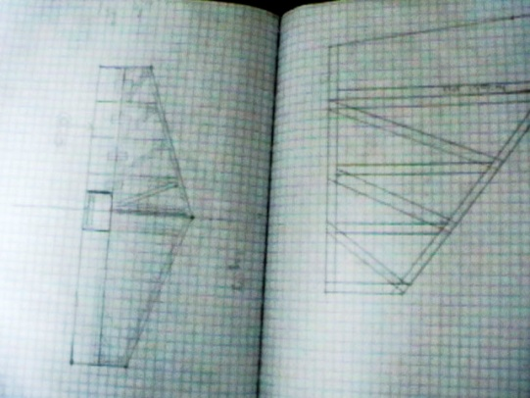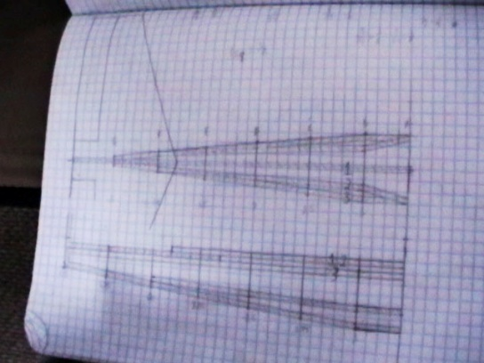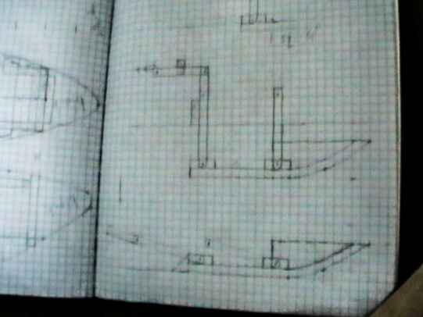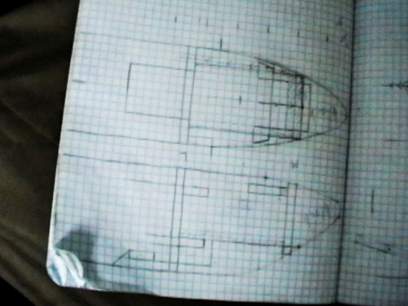

These are the basic components of constructions. Bulkheads and ribs were carefully cut out from the cardboard backings of my notepad books, and were typically 3-4 layers thick each. The spars and stringers were made by carefully drawing lines exactly 1/4" apart, and folding the paper into tight squares while using stick glue to harden it into place.

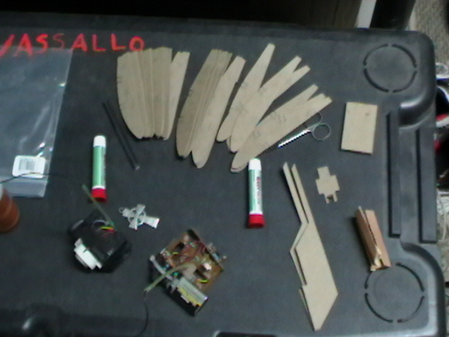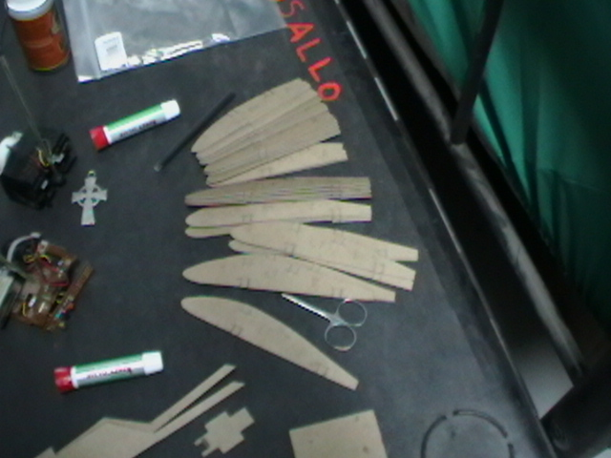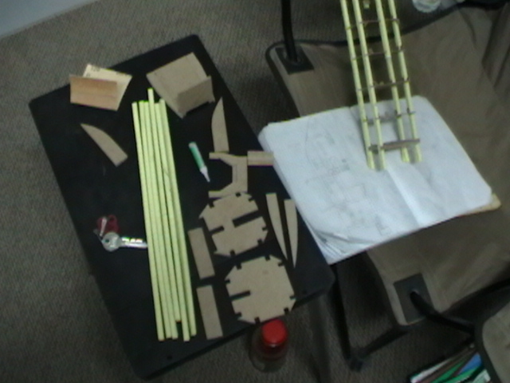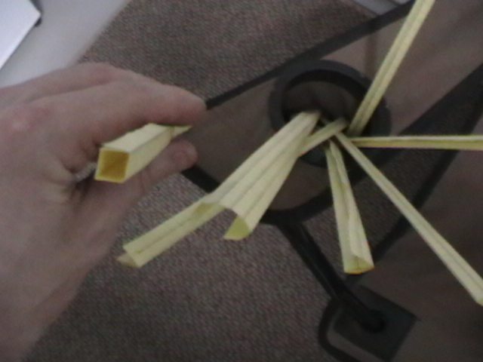

*Fun fact: During the construction of this airplane, I built a side project to help out our late night gate guards. The electronics shown in these two top pictures was scavenged from a broken R/C car. The transmitter was combined with parts from a nightlight to transmit when a vehicle's headlights shined upon it, and the receiver portion was combined with a peizo speaker to alert them when a vehicle was approaching.*

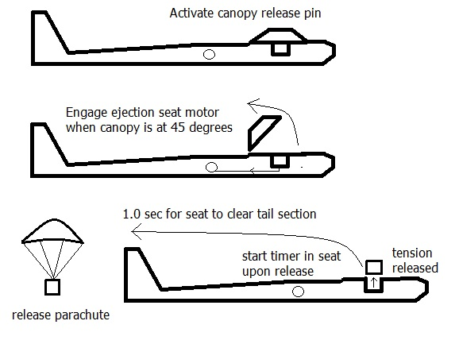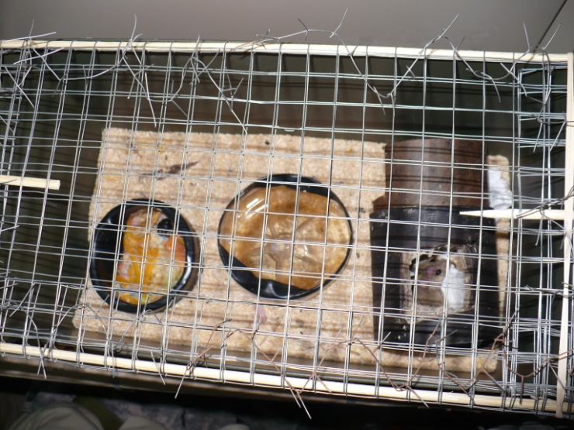The overall flow of the ejection seat process.

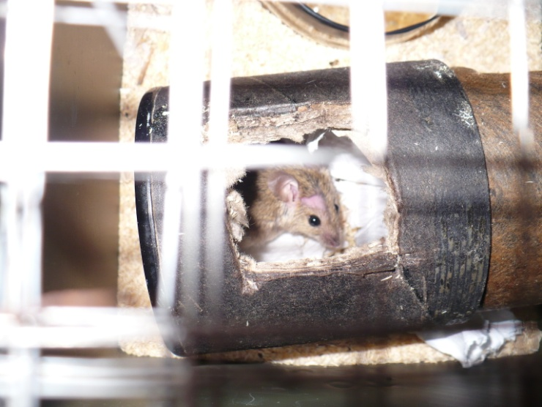

Our pilot was held in place by a custom suit that was tailored out of 550 chord and had a strip of velcro sewn into the back. The parachute was found inside of a mortar flare round.

Progress of construction...

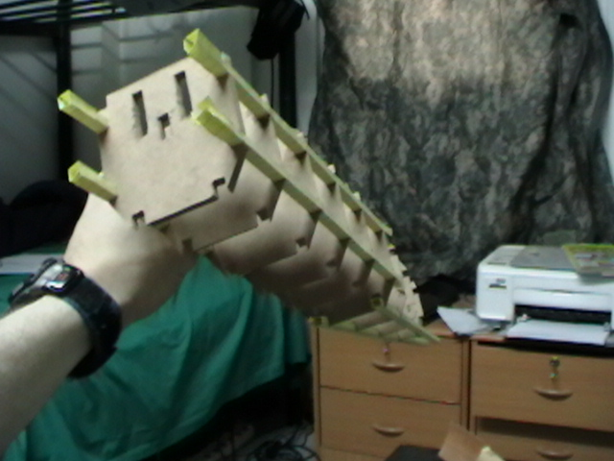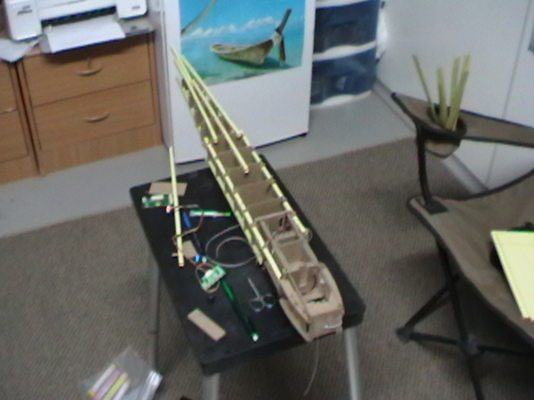

The ejection seat sat on top of a platform that could be raised by pulling on a set of four strings. These strings were later attached to large rubber bands with a lock and release system to hold it under tension and explosively release. The inner parts of a pen were used as string guides to eliminate friction. The dual 9v batteries located in the nose were pulled forward during the ejection process to counter-balance the immediate loss of pilot weight.

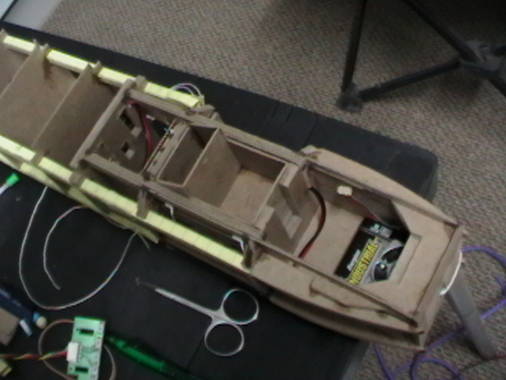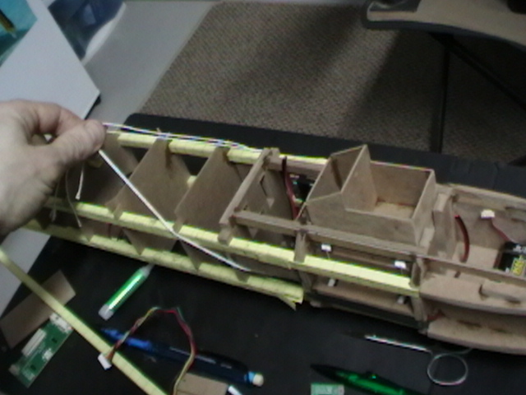

The forward retractable landing skid was constructed from outer pen casings and thumbtacks. It was designed to lock in place when fully extended and the small cardboard peices were soaked in superglue for strength. The servo attachment point is located behind the blue power switch and cannot be seen. The actual skid itself will not appear until later pictures. The string shown is for the ejection platform from the last step, and notice the nose and tail sections have not been permanently glued together yet.

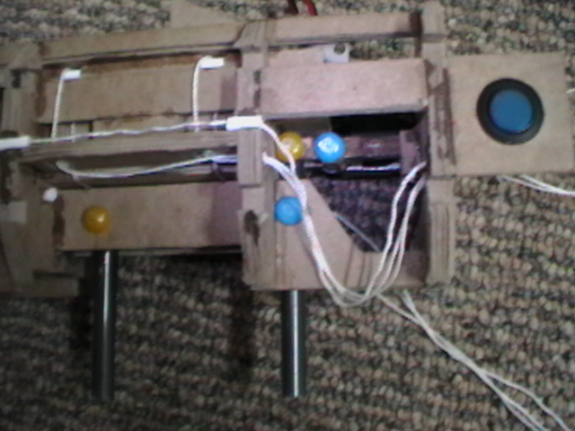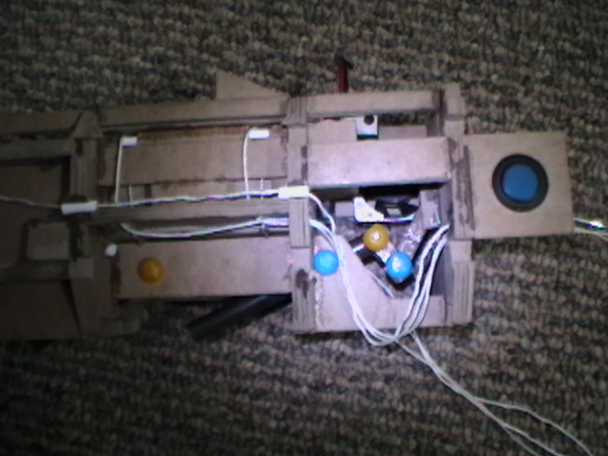

<http://www.alexvassallo.com/Projects/IraqAirplane/Video/FrontSkid.avi>

The wings were constructed on a large and perfectly flat surface. The center of the wing is reinforced by extra cardboard to prevent them folding up during flight. Large ailerons are controlled by using coffee straws and paperclips as pushrods, which attach to a common servo. Bellcranks were built using superglue soaked cardboard to translate pushrods 90 degrees to the ailerons.

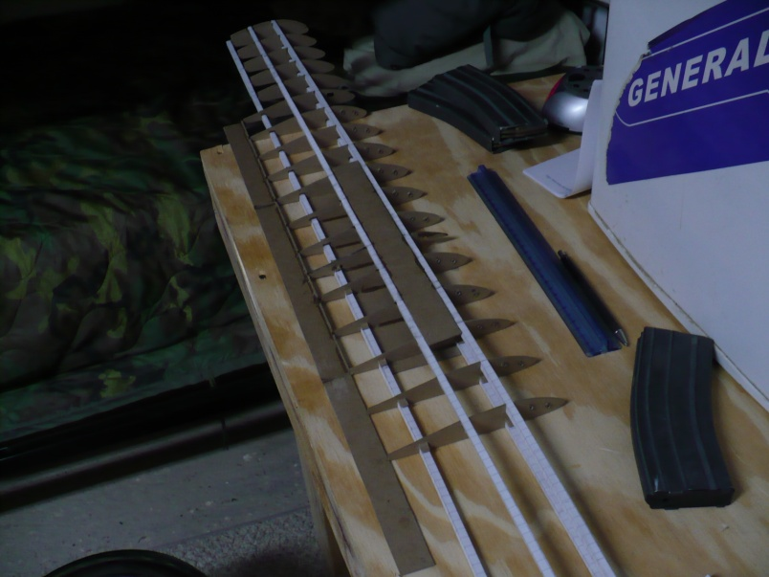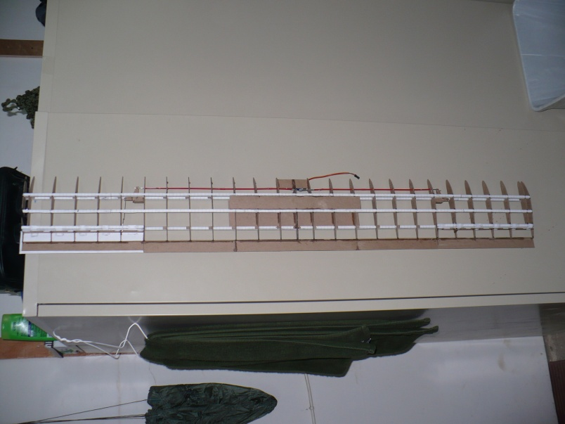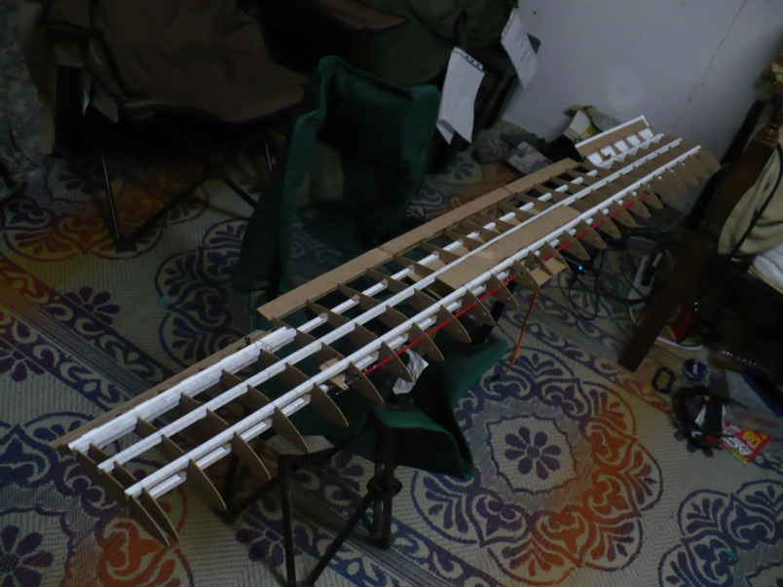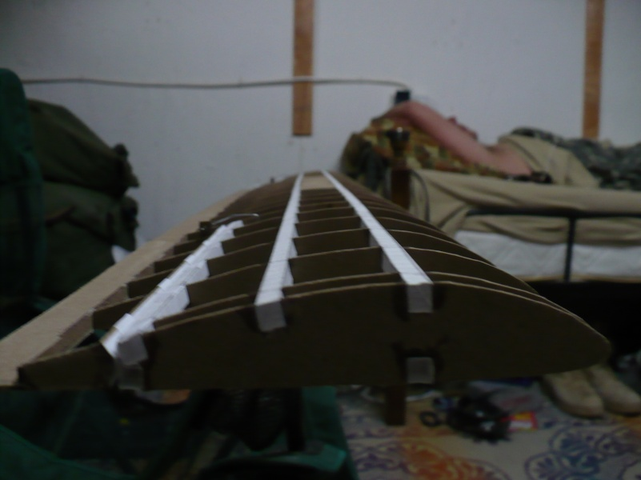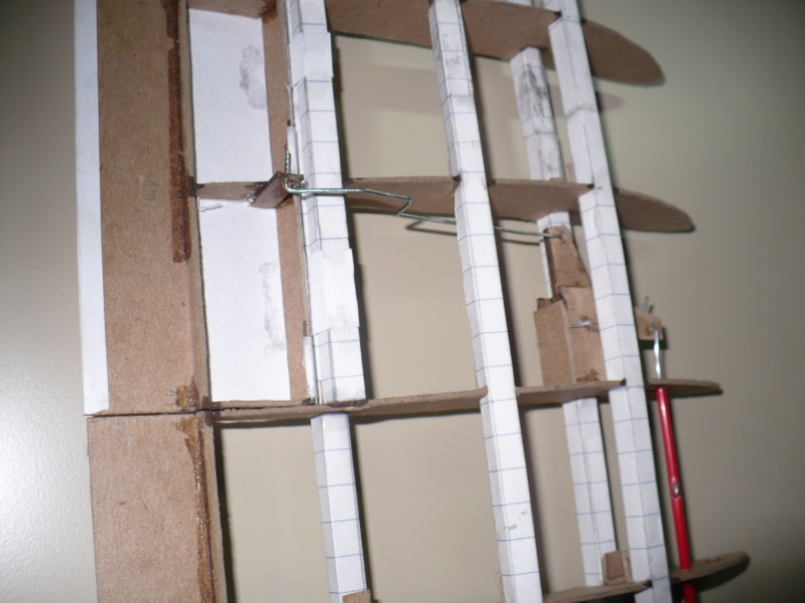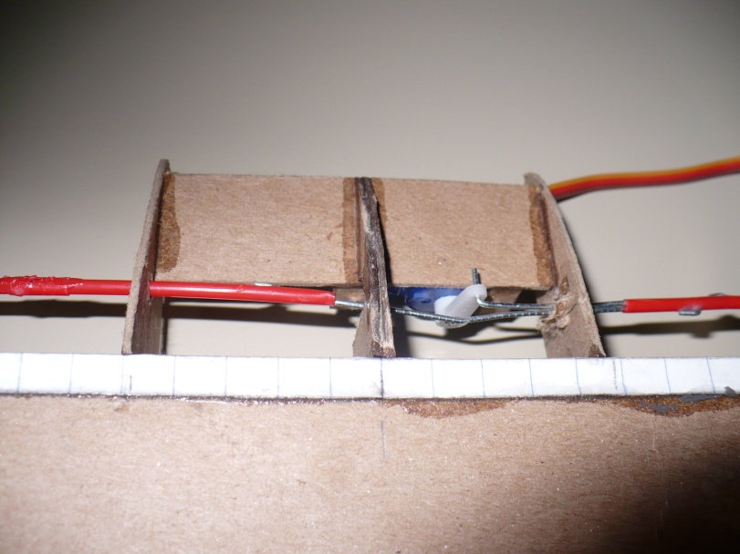

It may be noted that the color of the paper has changed to white. During construction, I was relocated to another station, which required me to dismantle most of the parts I had built. This new location had white notepads which I found much more aesthetically pleasing anyways. I reconstructed the tail section with this new paper. The elevator was built with a split surface design connected to a servo via coffee straws and paperclips, and the addition of LED navigation lights began. Cardboard was used to strengthen leading and trailing surfaces. 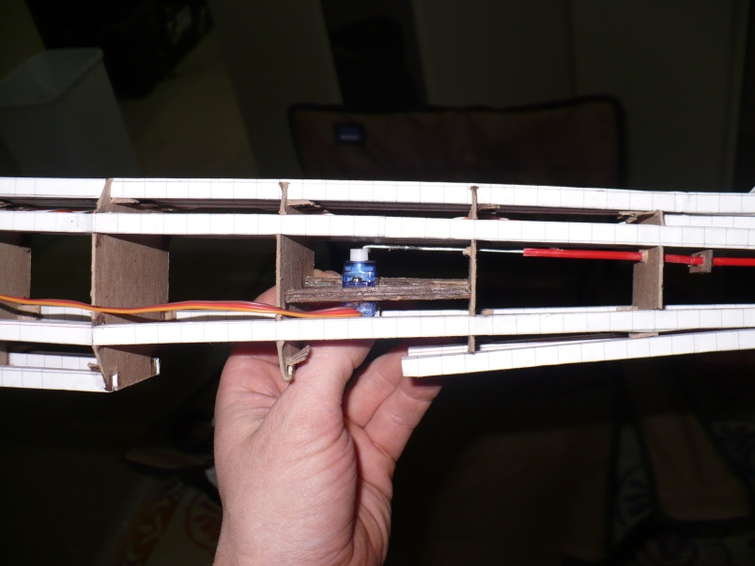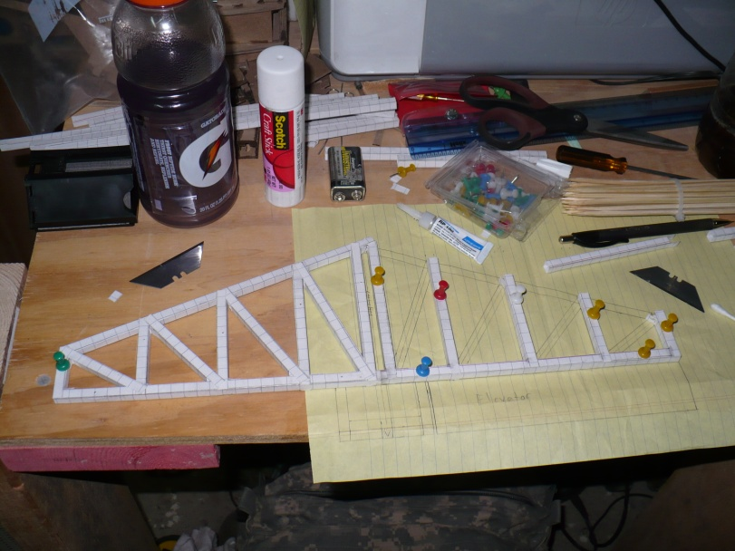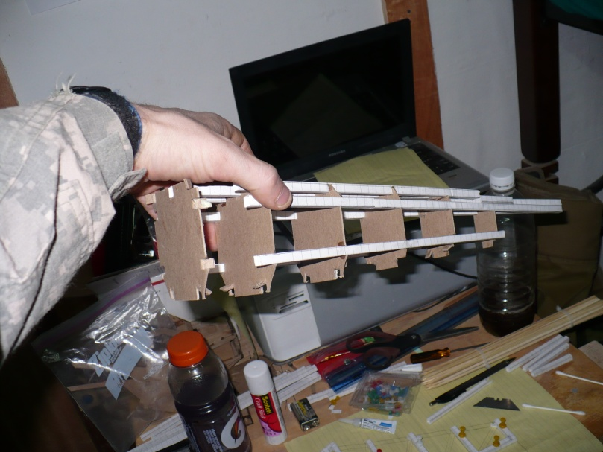 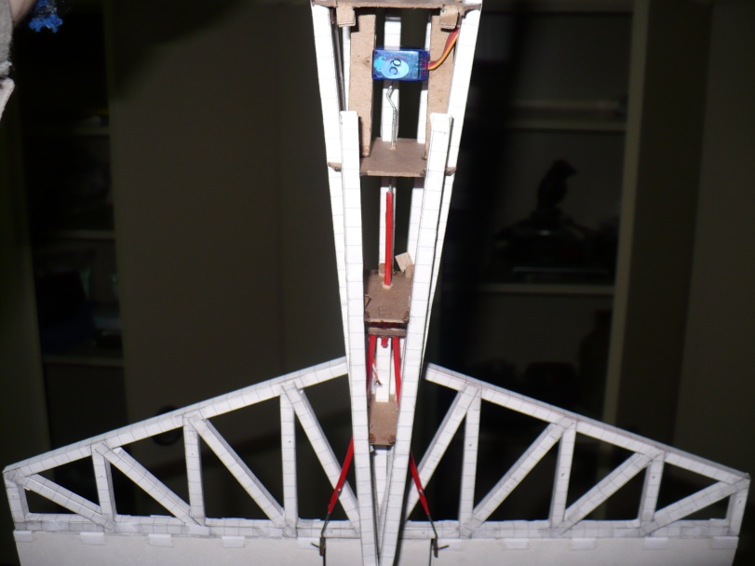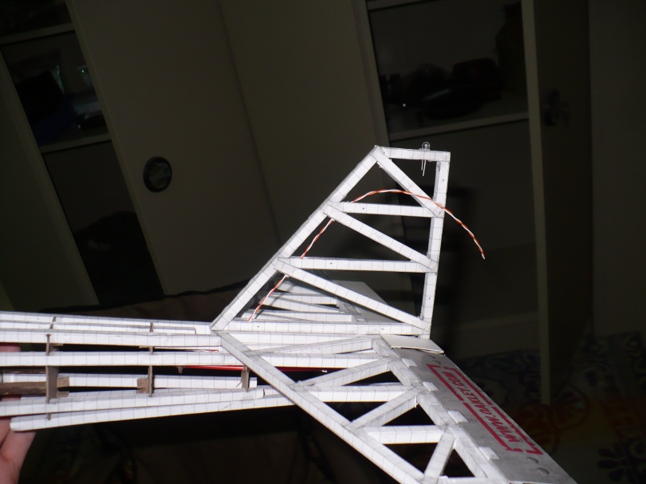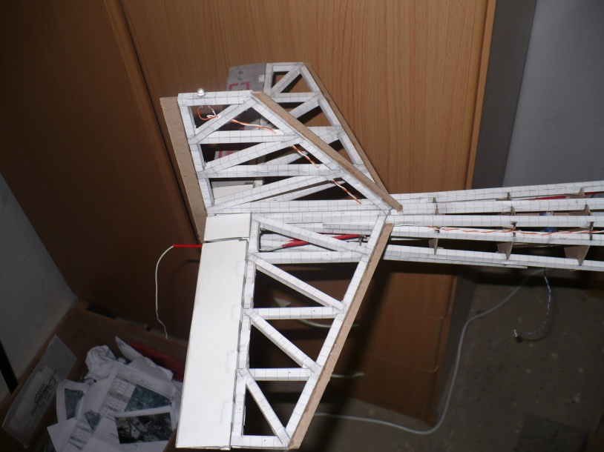

And now the more complicated peices. Here is the latch that holds the canopy down.

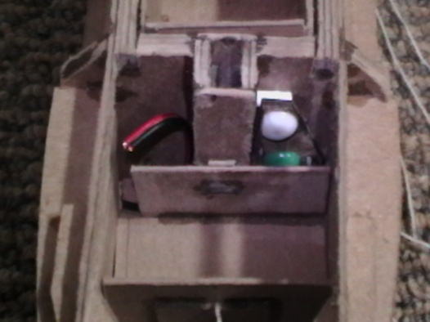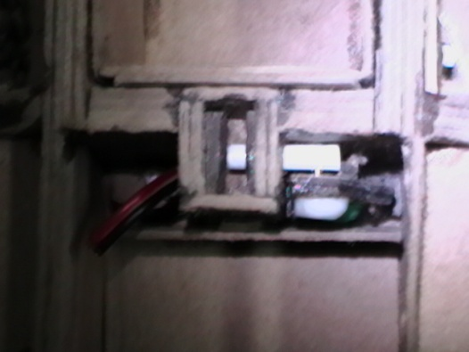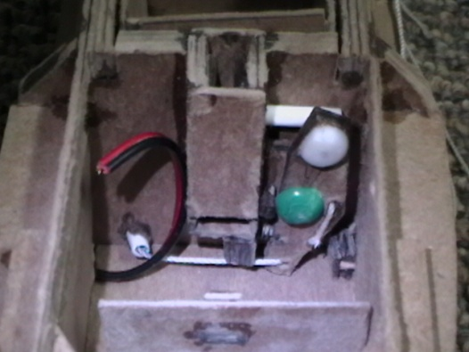

<http://www.alexvassallo.com/Projects/IraqAirplane/Video/CanopyRelease.avi>

Here is the ejection seat being built with a breakaway parachute box, a timer, and a PWM servo controller.

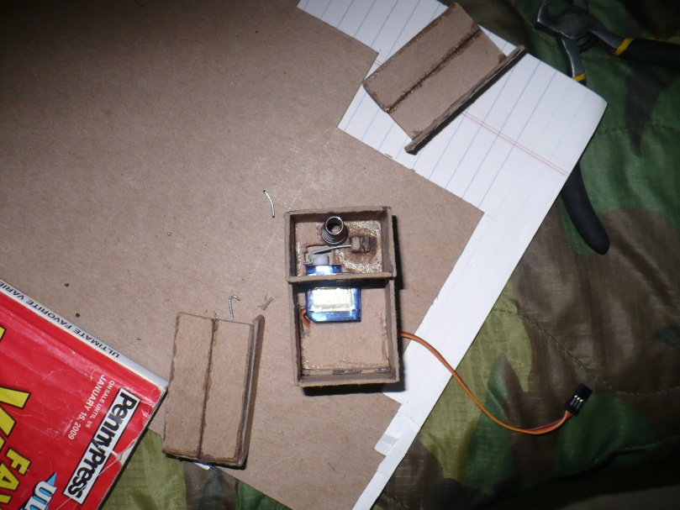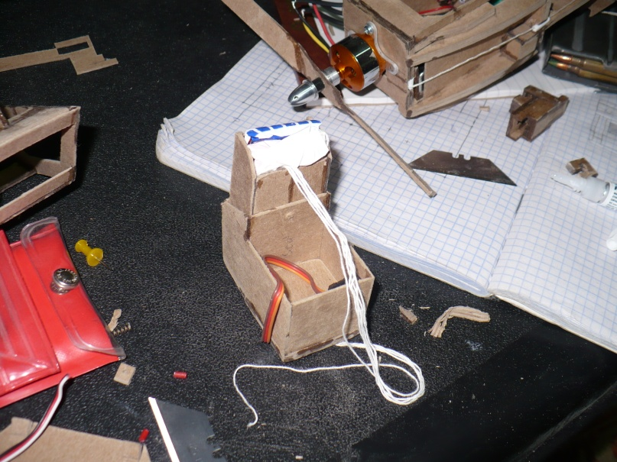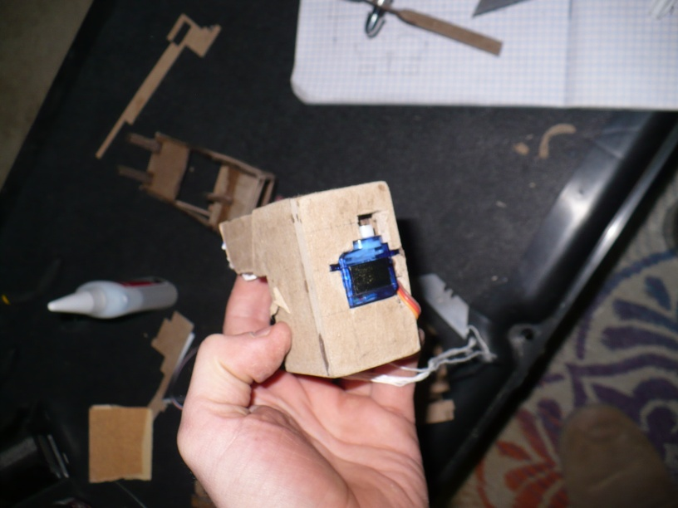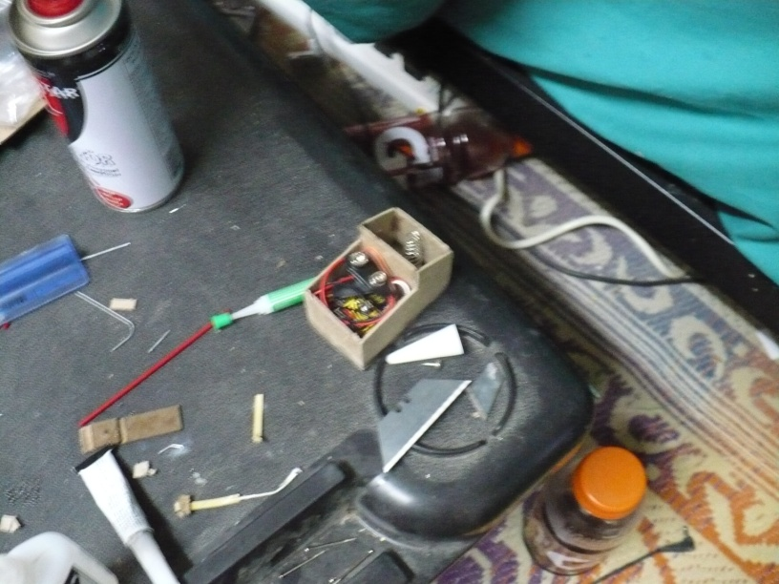

*Large circuit was later reduced in size to fit pilot and a small battery fit into the corner. Contacts on the bottom were later added to detect when it had ejected.*

Here are the latches that held back the huge tension that ejected the seat. The latches were release by activating a large motor connected to a gear box, that was salvaged from a R/C car, which pulled a common release string. These parts were the most difficult to build. The release strings had a tube glued into an exact alignment, which rested in this catch.

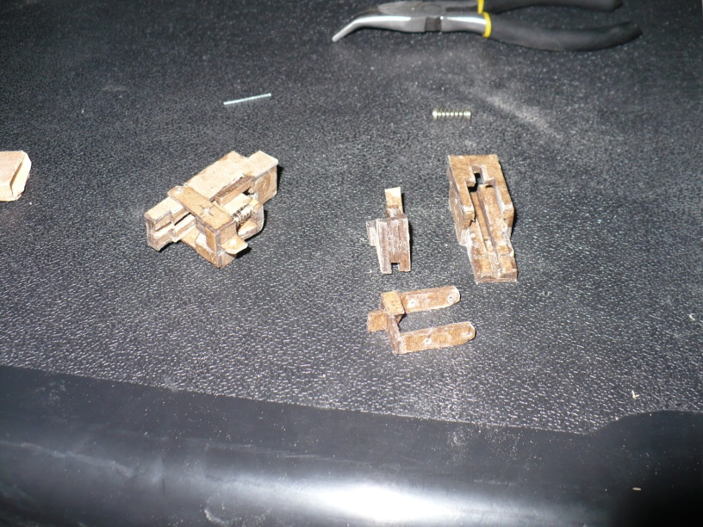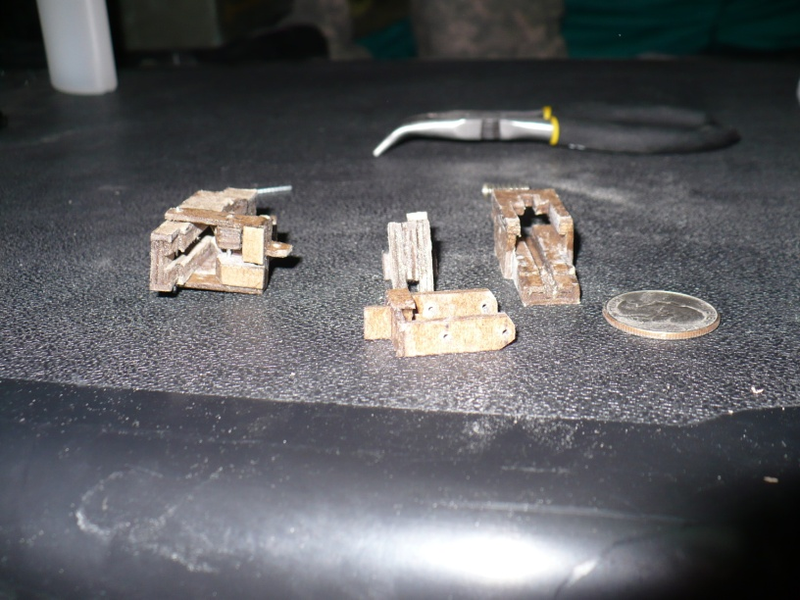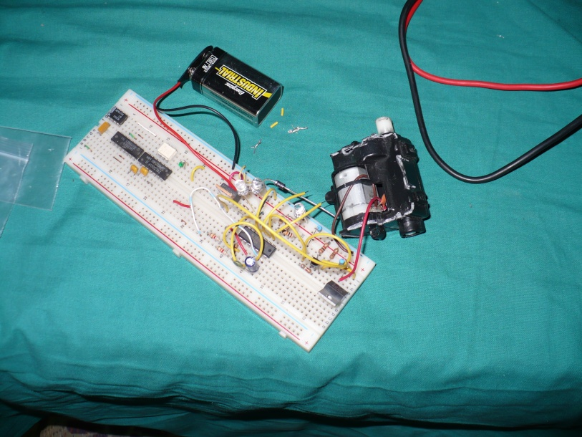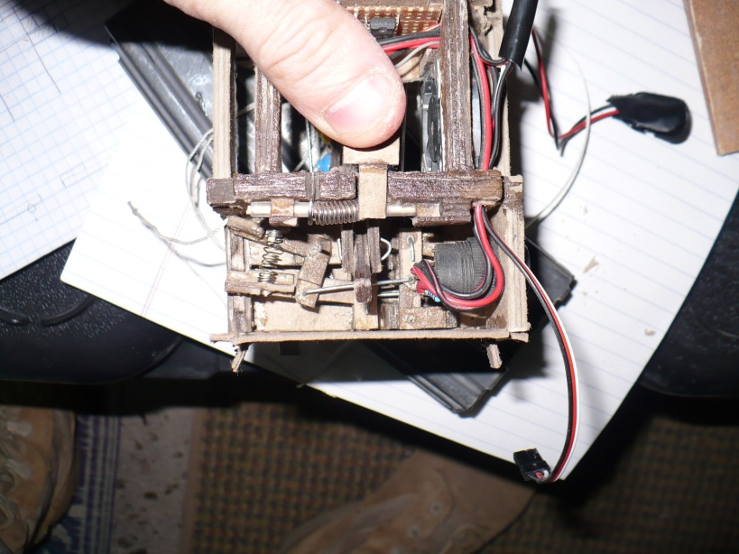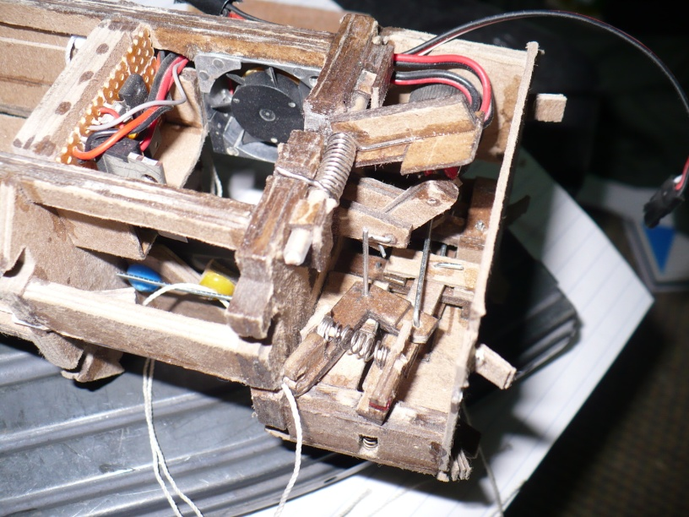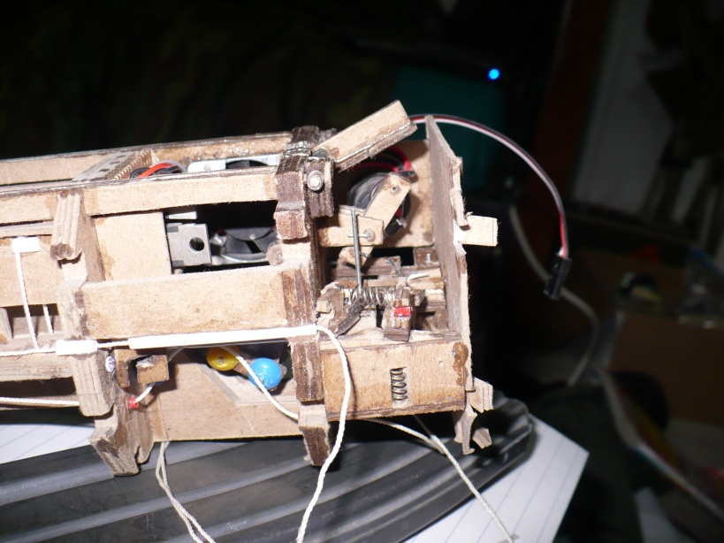

Servo bay, receiver, motor, motor controller, and forward landing skid. The propeller shown is only for testing. The motor which pulls the ejection seat release will be mounted into the open bay shown in the bottom right picture.

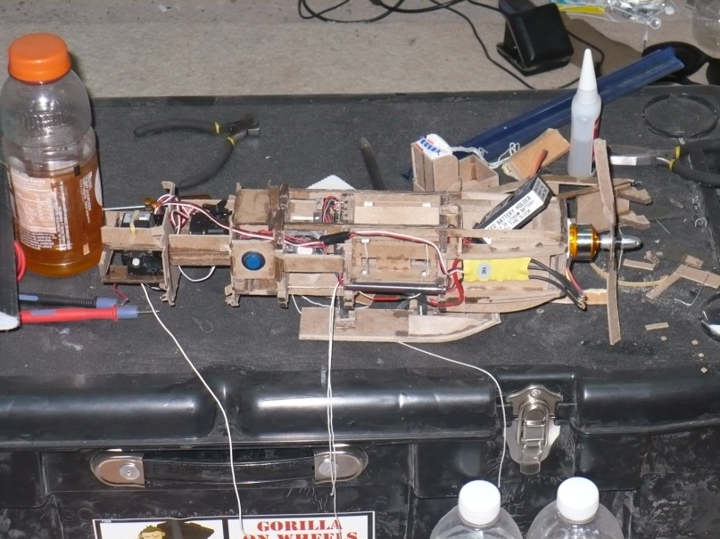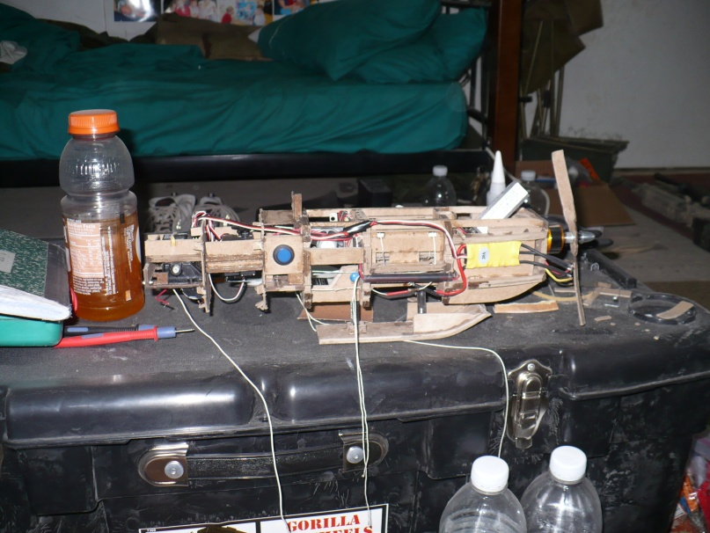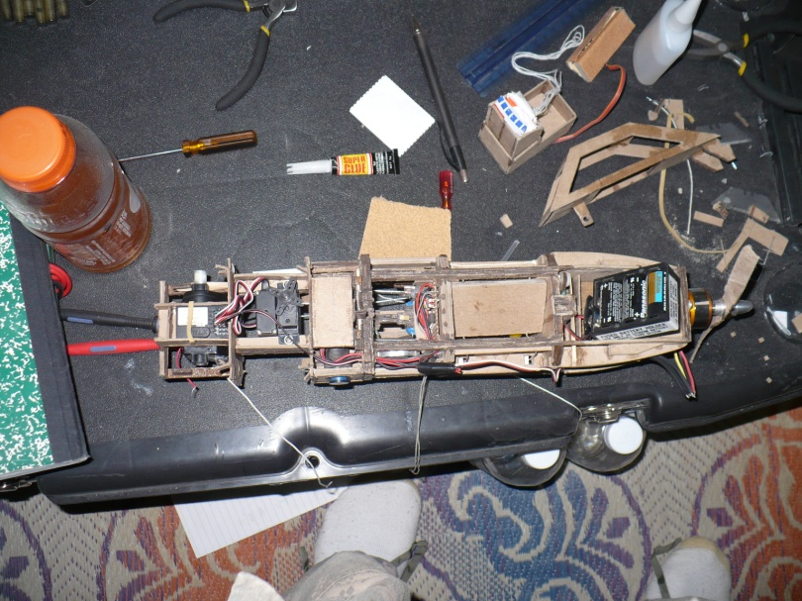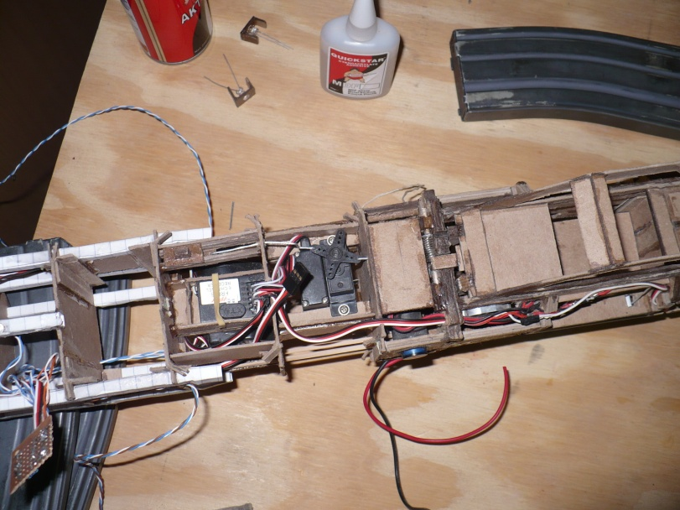

Folding propeller blades. Superglue hardened cardboard with plastic tube hinge points.

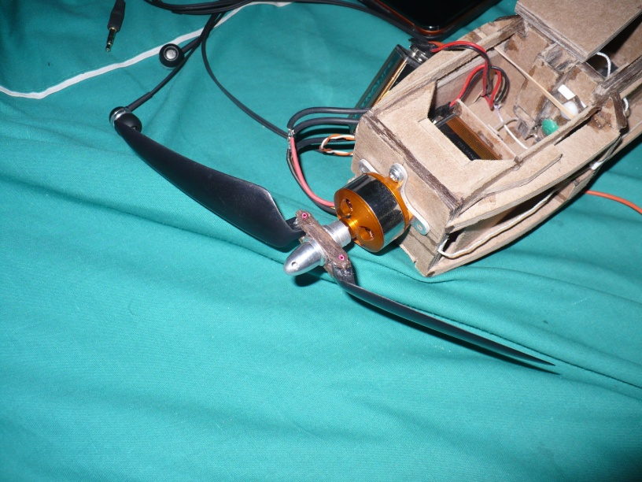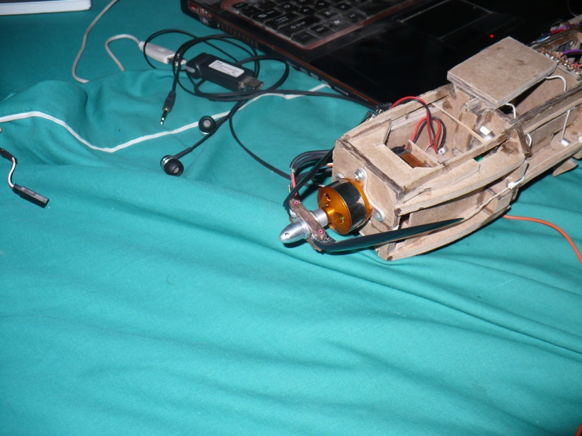

Rear retractable landing skids. Like the front landing skid, these also lock into place when fully extended. 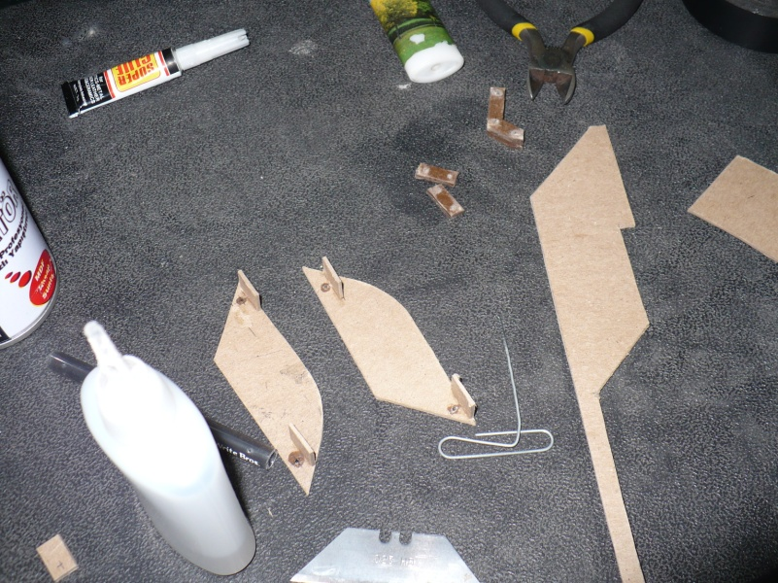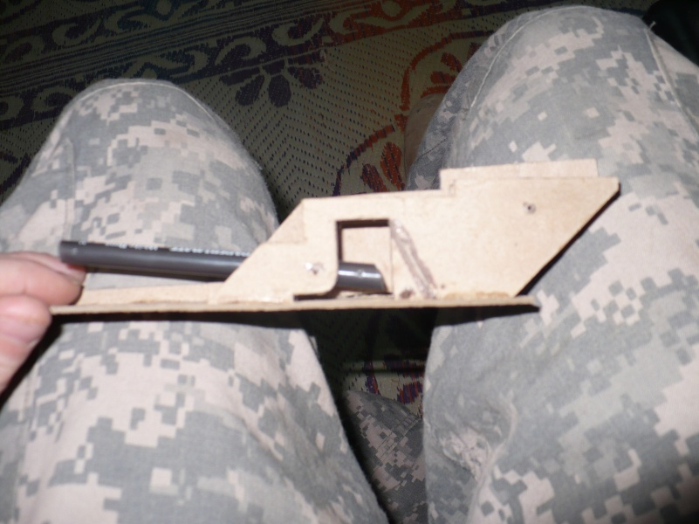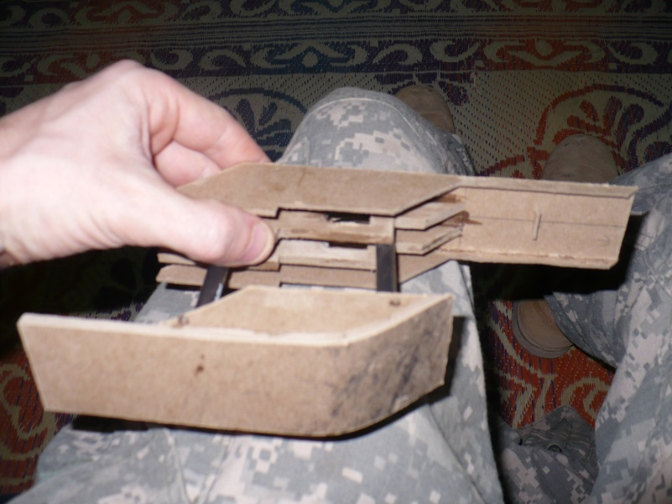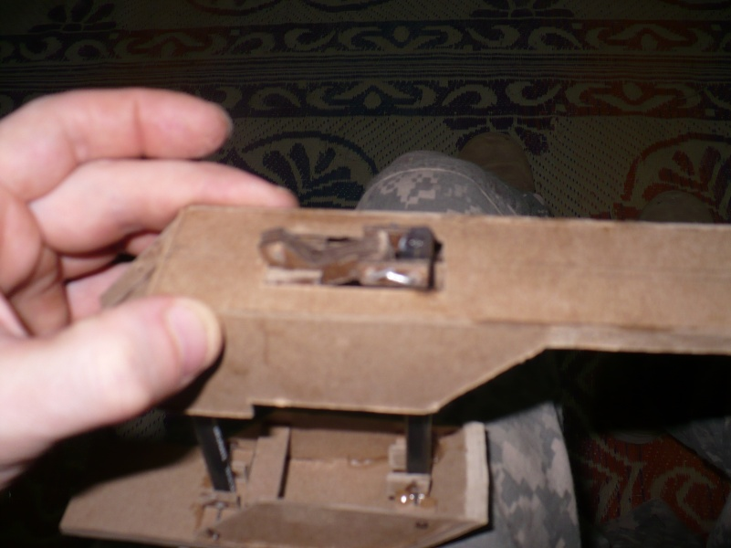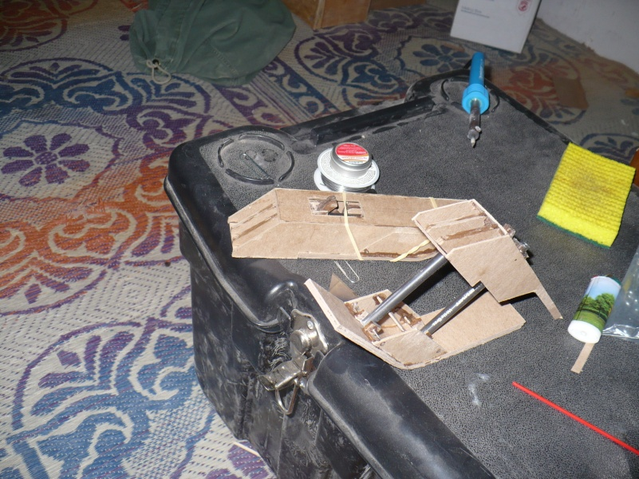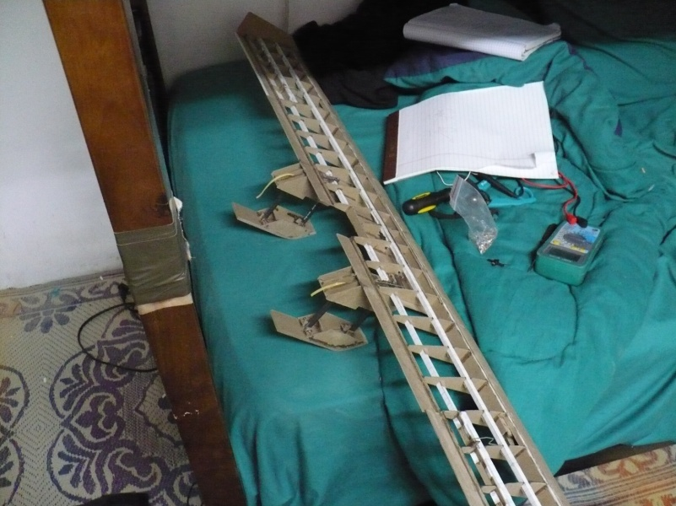

<http://www.alexvassallo.com/Projects/IraqAirplane/Video/MainSkids.avi>

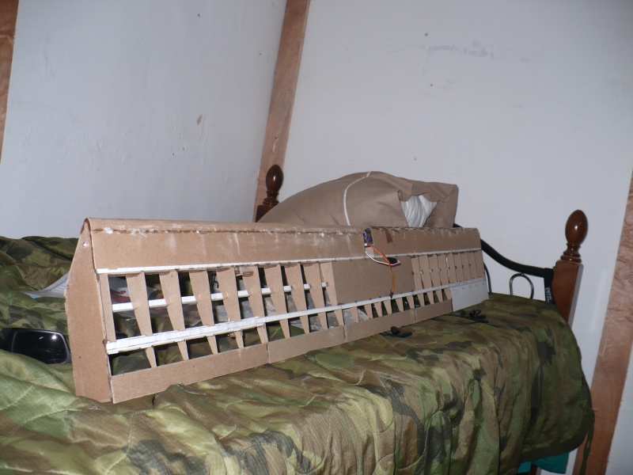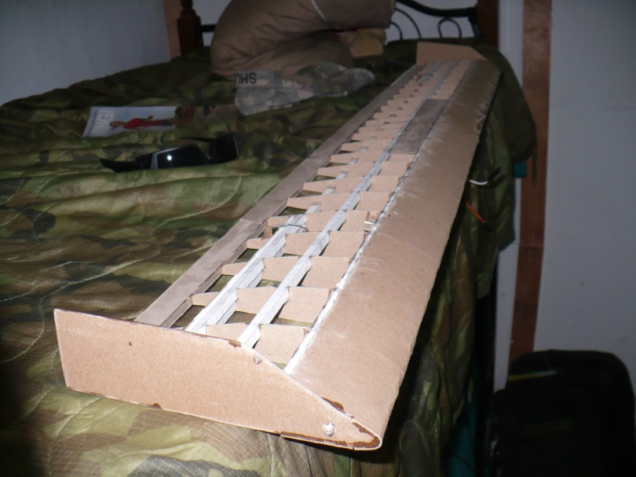 The leading edge was added by rolling cardboard over the ribs. This actually made the wing structure incredibly strong, much stronger than expected. Wingtip plates were also added to reduce the wing tip vortex produced by the large chord of these wings.

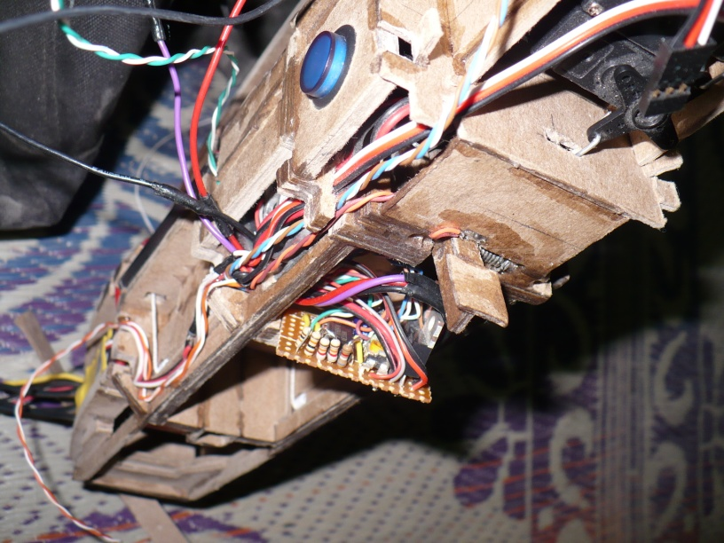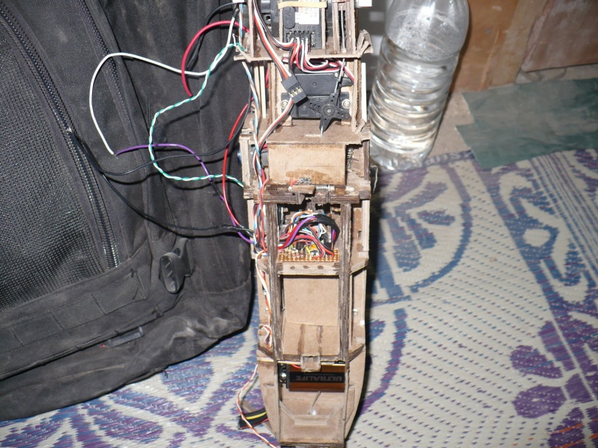 This onboard circuit served many purposes. It held 5v regulators needed to reduce the voltage of the 9v batteries. It contained a 556 chip (dual 555) which controlled a blinking strobe light, and triggered the 1st phase of the ejection process. The 4 volt drop across the 5v regulator (7805) produced enough heat to require a cooling fan.

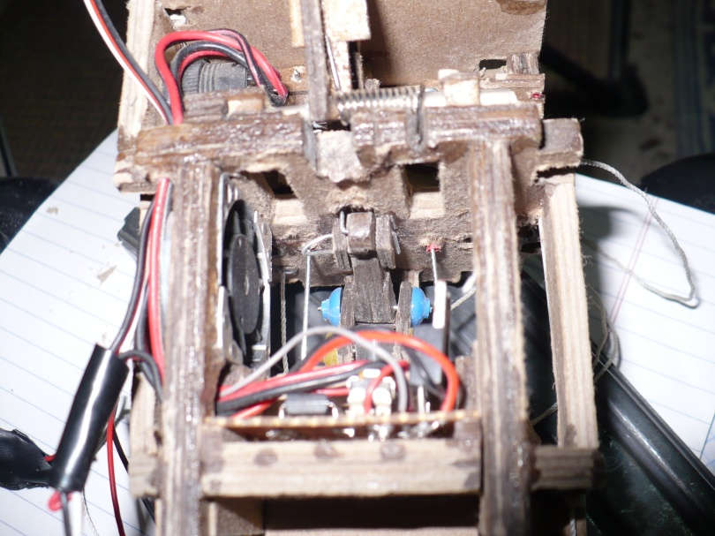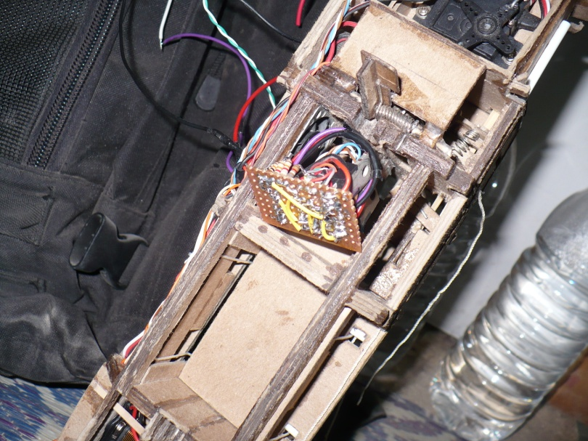

The navigation lights followed the standard convention for aircraft. Green on the right, red on the left, red on the tail, a white strobe on the belly, and two super bright landing lights located inside of the forward skid compartment, which only turned on when the landing skids were fully extended..

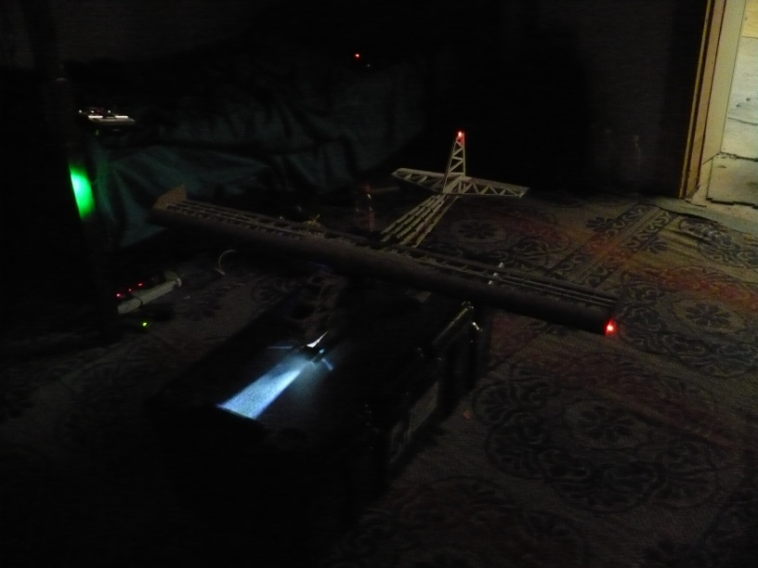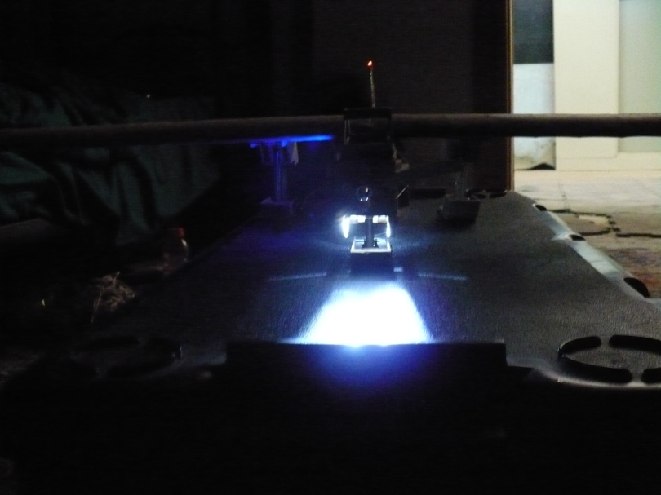

<http://www.alexvassallo.com/Projects/IraqAirplane/Video/Lights.avi>

This latch was designed to hold down a large spring-loaded parachute box which was to be deployed in the event of radio failure. Military bases commonly used radio jammers to prevent missile and IED attacks. These jammers could completely disrupt radio communication with the airplane. This latch was designed as a multi-stage locking latch which could hold back a huge amount of tension, but be easily released by the small force applied by a microservo.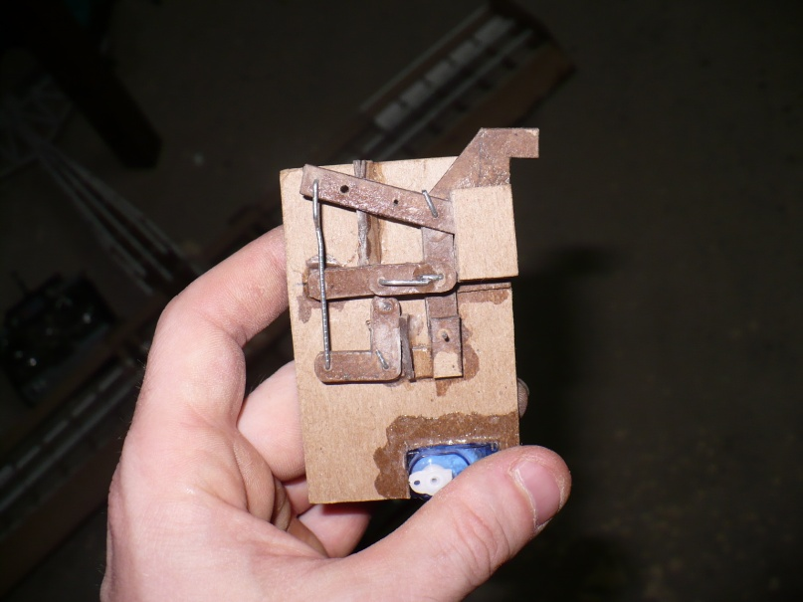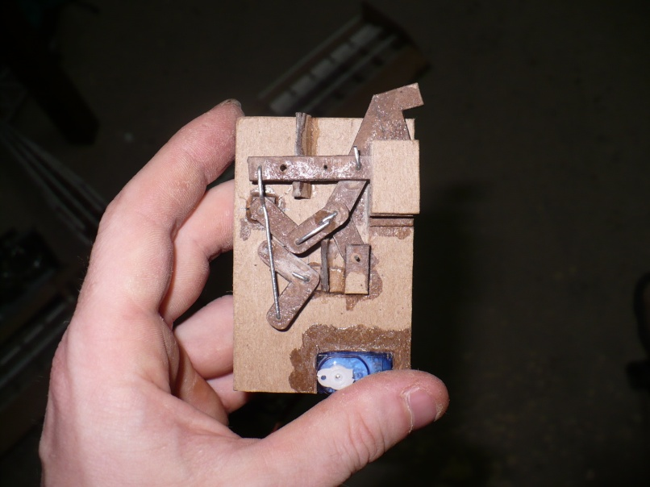

<http://www.alexvassallo.com/Projects/IraqAirplane/Video/ParachuteRelease.avi>

All the peices coming together. The wings connected to the fuselage via two large platic bolts, and a set of male and female connectors which perfectly aligned with each other. Two square blocks on the wing mated with two square holes on top of the fuselage to allow for easy installation.

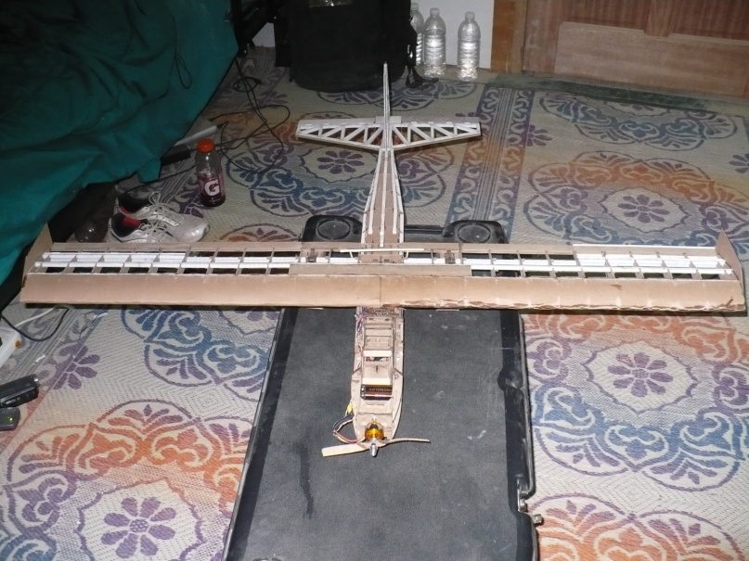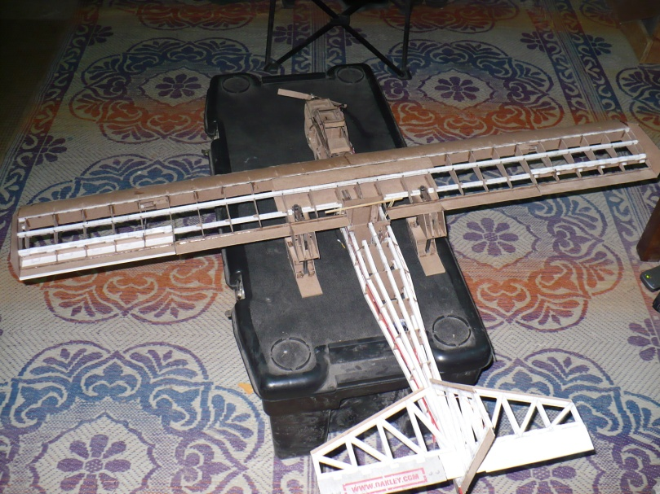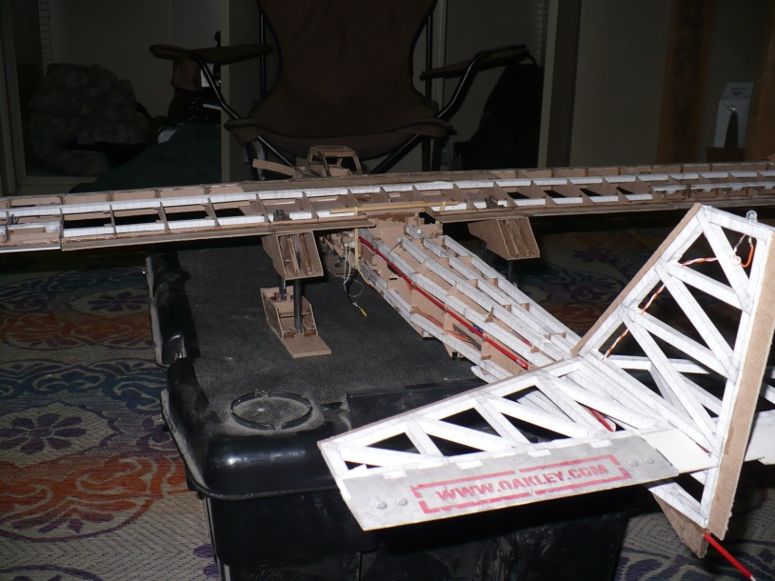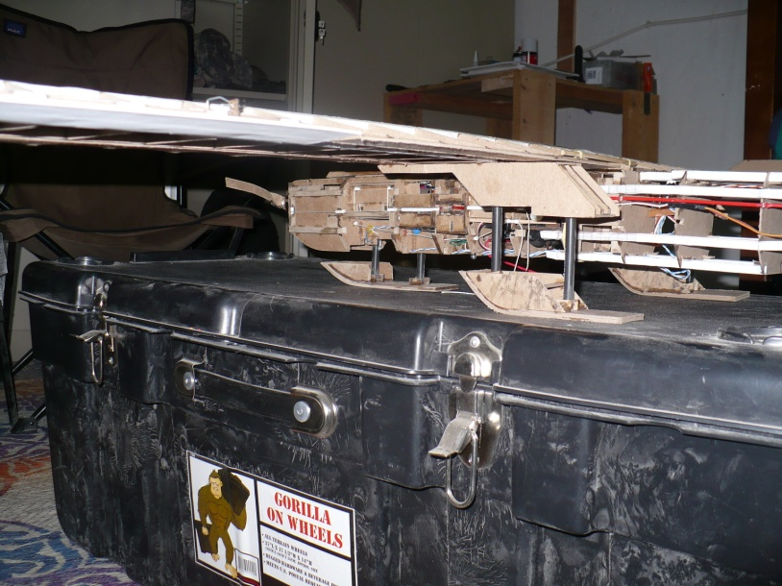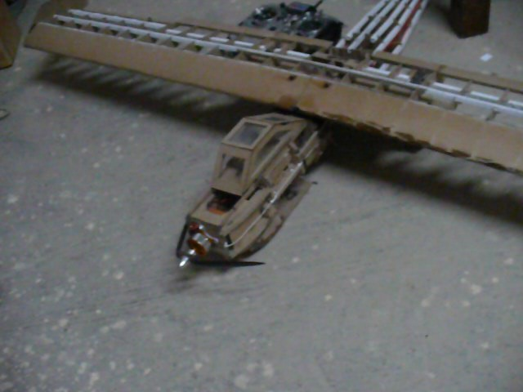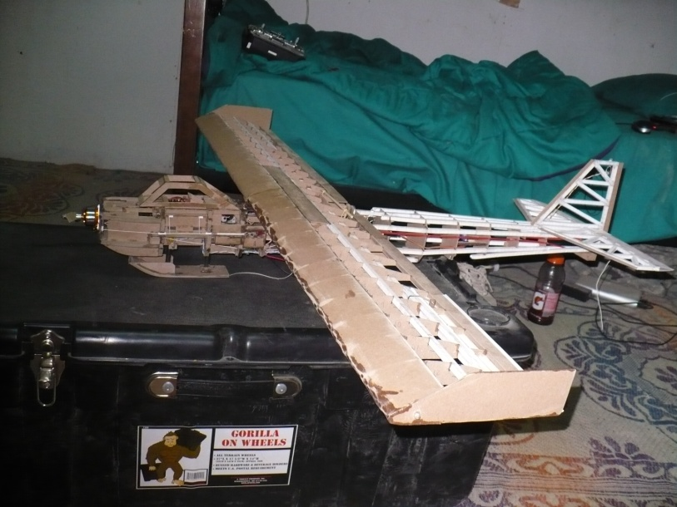

<http://www.alexvassallo.com/Projects/IraqAirplane/Video/Walkthrough.avi>

<http://www.alexvassallo.com/Projects/IraqAirplane/Video/RadioTest.avi>

The majority of the aircraft was now covered with normal white printer paper from the supply tent. The batteries for the motor were built into a disposable pod which sat streamlined on the belly, and made contact with two large metal connectors. Due to weight, this battery pack was designed to be jettison before landing. The canopy openings were covered by cellophane from a pack of cigarettes. The landing skids were covered with aluminum from a soda can. A curved nose cone was carefully built by soaking cardboard in water and allowing it to dry around a mold, then applying superglue to harden it into form. All systems appeared to be working as expected.

We then received notification that our tour in Iraq was complete. The aircraft was carefully packed up in a custom made box, tightly secured, and then mistaken as a malicious package and mostly destroyed. Here are the pictures of its final condition.

